Practice Exercise 2

**Instructions – please read carefully**

* If you are asked to write a program, then below the question, please add a screenshot of the program shown in the Editor window **and** a screenshot of the program being run in the Shell window.
* Some of the questions require answers – type those where the dotted line is
* The questions where the numbers are coloured green are compulsory.
* The questions where the numbers are coloured yellow are extension work and optional. We would recommend if you complete the work set in 30 minutes or less, you should attempt these.

1. Write a program in the Python editor that assigns the variables length and width as 18 and 7 respectively. Use the variables to calculate the perimeter and area of the rectangle.

Screenshots here:

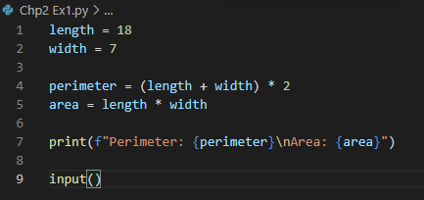

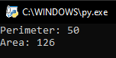 ❑

2. Write a Python program that defines a variable called *days_in_school_each_year* and assign 192 to the variable. The program should then print out the total hours that you spend in school from Year 7 to Year 11, assuming that each day you spend 6 hours in school.

Screenshots here:

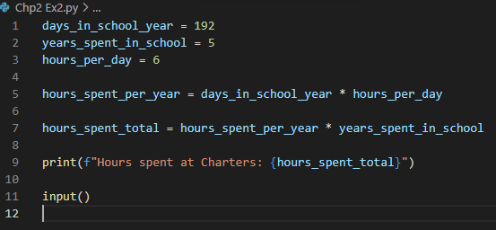

 ❑

3. What value will be printed on the screen?

*marks = 25*

*marks = marks + 10*

*print(marks)*

**35**

**Hint:** We use # to include comments in our code.   
Comments are ignored by the interpreter; they are   
meaningless for the interpreter but give more information to us humans.

4. Given the code below, what value will be printed to the screen?

*time_spent = 34 # in minutes*

*# after one minutes*

*time_spent = time_spent +1*

*print(time_spent)*

**35**

…………………………………………………………………

5. Which of the values below would be printed on the screen from the code snippet?

Perhaps easier if your wrote this program and tried it.

* 1. **5040**
  2. *210*
  3. *720*
  4. *Error*

*hours_in_a_week = hours_in_a_day * 7*

*hours_in_a_month = hours_in_a_week * 30 # assuming we have 30 days in a month*

*print (hours_in_a_month)*

6. What is the value of score after running the following code?

*score = 24*

*number_of_pieces = 2*

*new_score = score *2*

**24**

7. a. True or false? An expression can be assigned to a variable.

**True**

b. What is the value of y after running the code?

*x, y = 23, 45*

*y, x = x, y*

**23**

8. Which of the following are not valid Python variable names?

|  |  |  |  |
| --- | --- | --- | --- |
| name | country1 | item34 | 4gs |
| &item | _age | bestHeight | tHiSiSaVaRiAbLe |